User’s JSON Login | User ID | Role ID
{  "email": "toadsworth@mariokart.com",  "username": "Toadsworth",  "password": "TallyHoPassword"  } | 1 | 1
{  "email": "egadd@mariokart.com",  "username": "ProfessorEGadd",  "password": "Poltergust3000"  } | 2 | 2
{  "email": "starlow@mariokart.com",  "username": "Starlow",  "password": "HelloYello"  } | 3 | 3
{  "email": "goomba@mariokart.com",  "username": "Goomba",  "password": "EliteTrio"  } | 4 | 4

Create a User Screenshot (before registration)

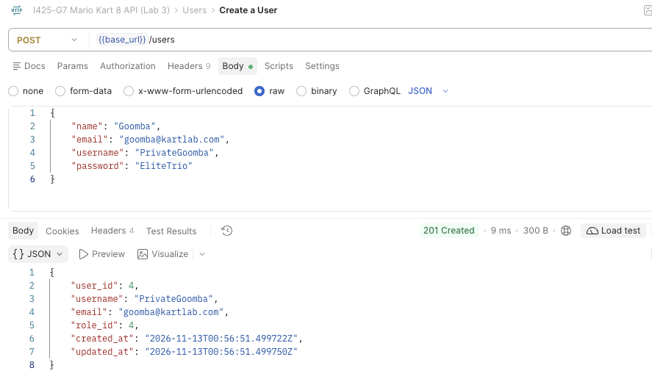

Update a User Screenshot
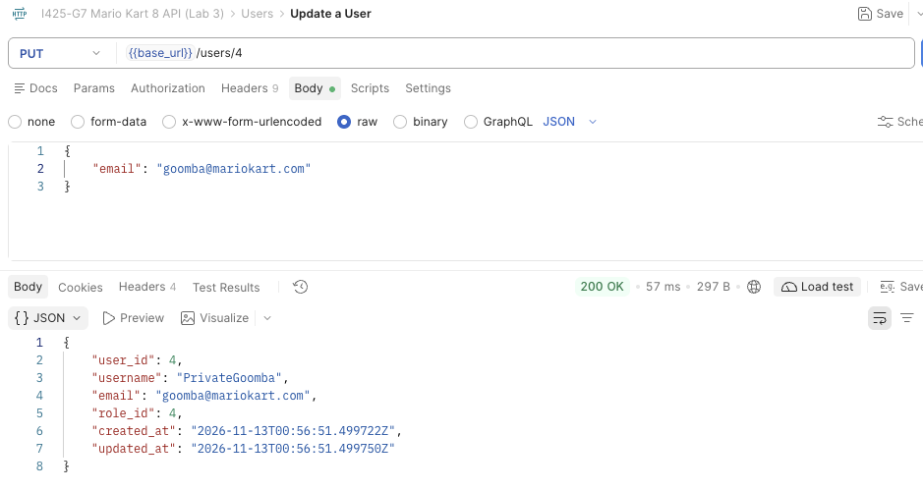

Delete a User Screenshot
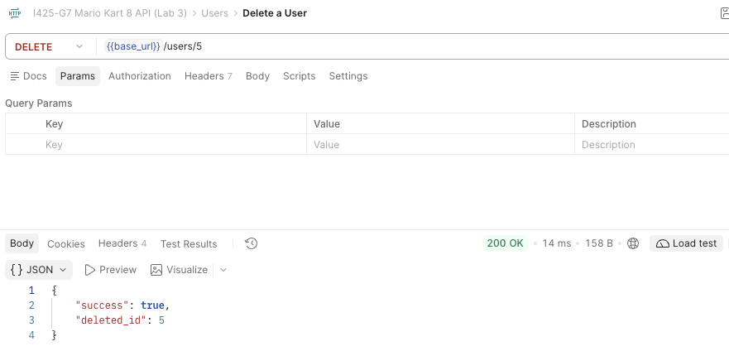

Get Users Screenshot
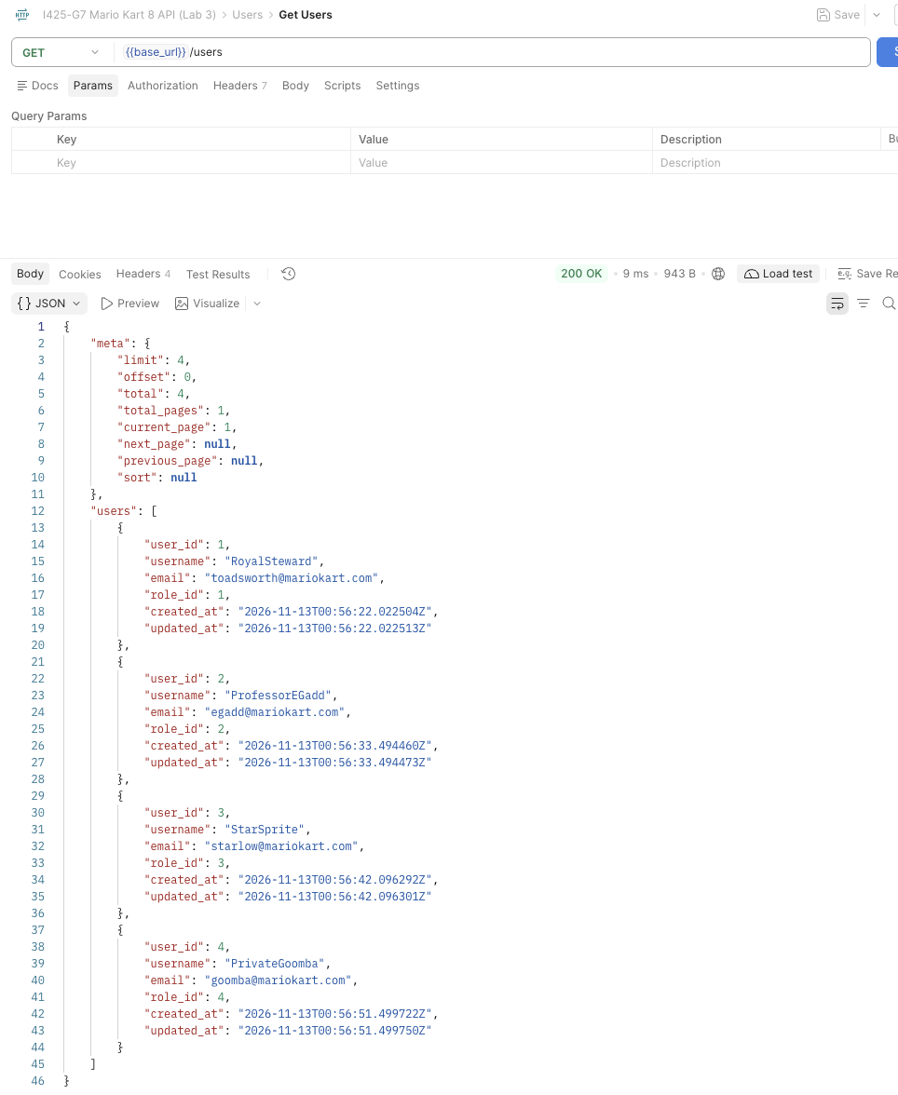

User Registration Screenshot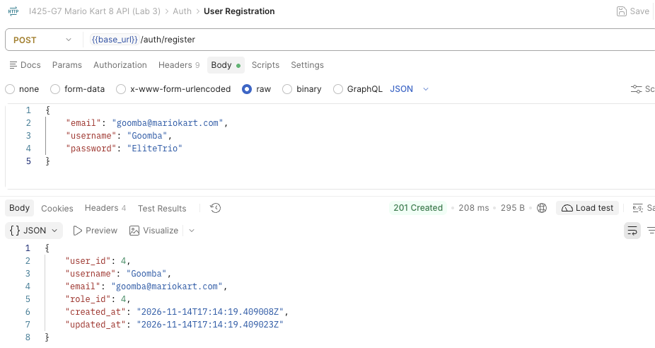

User Login Screenshot (before roles were assigned)
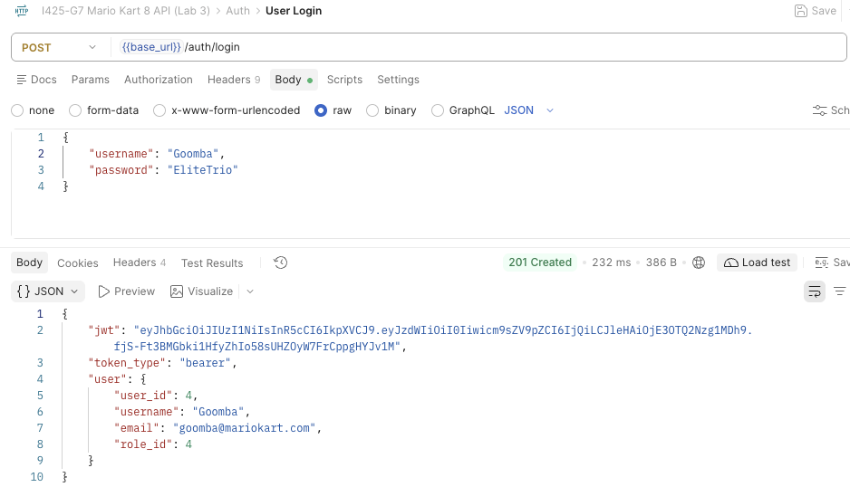

Authentication to “Get All Bodies” if user has not logged in
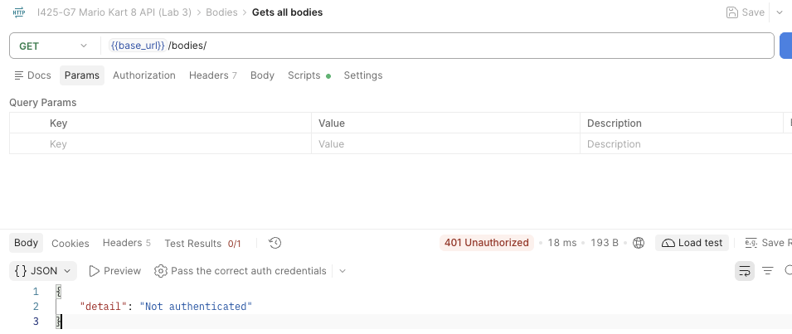

Screenshot of an Authenticated User to “Get All Bodies” using a jwt token
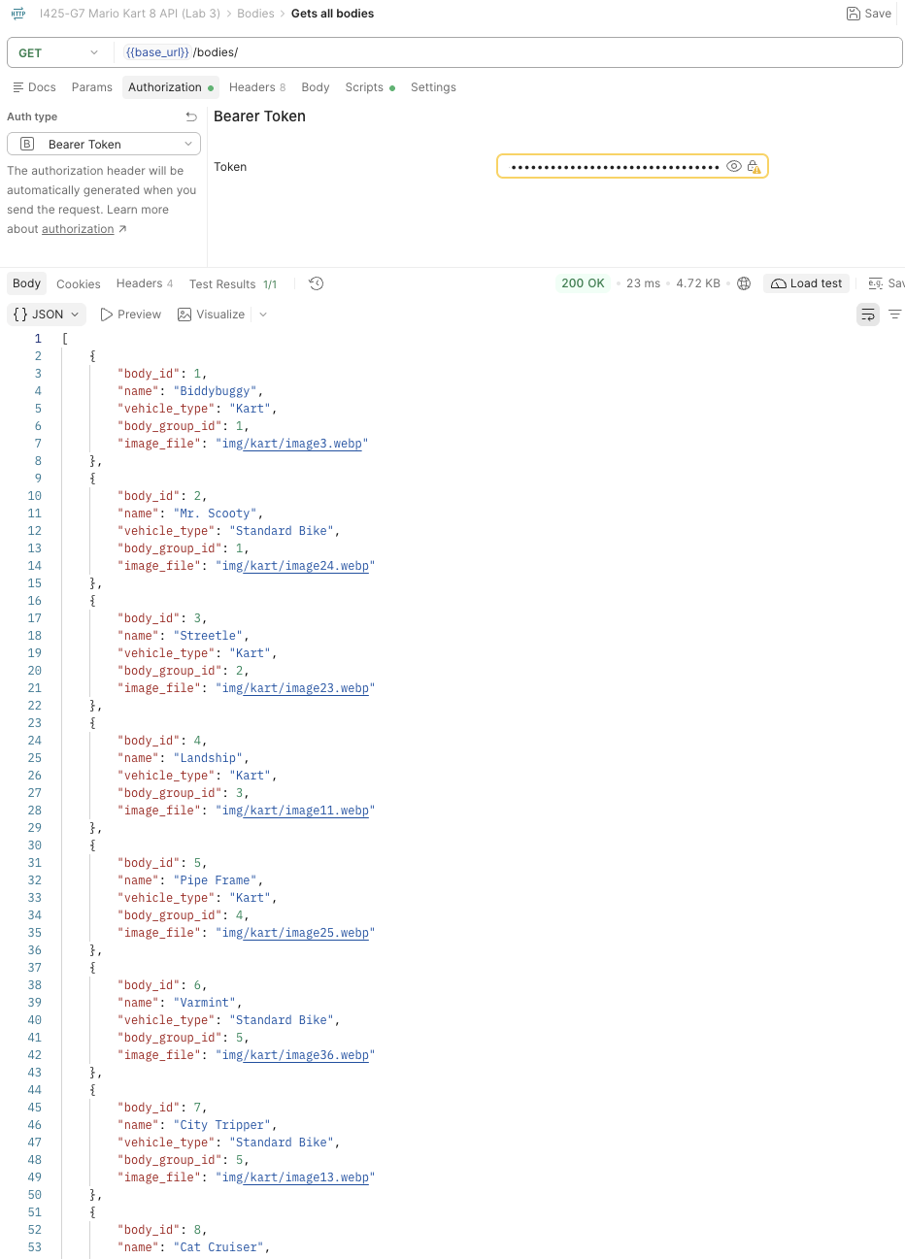

Screenshot of an unauthenticated user trying to create a user


